CHAPTER TWO
LITERATURE REVIEW
────────────────────
A Comprehensive Survey of VFFS Technology,
Powder Rheology, and Auger Filling Systems

CHAPTER TWO: LITERATURE REVIEW
The development of automated packaging systems for powdered materials represents a sophisticated convergence of mechanical design, granular mechanics, and mechatronic control engineering. This chapter presents a critical review of the fundamental engineering principles and state-of-the-art advancements in Vertical Form-Fill-Seal (VFFS) technology and auger-driven dosing mechanisms, establishing the theoretical foundation for the mechatronic system developed in this project.

2.1 VFFS and Dosing Technologies
Vertical Form-Fill-Seal (VFFS) technology represents a cornerstone in modern automated packaging, particularly for granular, powdered, and liquid products. Its efficiency stems from the integrated process of forming a bag from a roll of film, filling it with the product, and then sealing it, all within a continuous vertical motion. The efficacy of a VFFS system is intrinsically linked to the precision and reliability of its dosing mechanism, which dictates product consistency and economic viability. This section delineates the operational principles of VFFS machines and provides a comparative analysis of volumetric versus gravimetric dosing technologies, highlighting their respective advantages, limitations, and suitability for various industrial applications.

2.1.1 Operating Principles of Vertical Form-Fill-Seal Machines
The Vertical Form-Fill-Seal (VFFS) machine constitutes a cornerstone technology in modern automated packaging, integrating three distinct yet kinematically synchronized operations—forming, filling, and sealing into a single continuous production cycle [1]. Since its commercial introduction in the mid-20th century, VFFS technology has evolved from simple mechanical cam-driven systems to sophisticated mechatronic architectures incorporating advanced servo control, real-time process monitoring, and adaptive adjustment capabilities [2].

Kinematic Sequence and Film Handling
The operational sequence of a VFFS system initiates with the tension-controlled unwinding of flexible packaging film from a supply reel. The film web is drawn through the machine via motor-driven friction belts or vacuum pull mechanisms, with precise tension regulation maintained through dancer roller assemblies and electronic feedback systems to prevent wrinkles, stretching, or misalignment that would compromise package integrity [3]. The film subsequently passes over a forming collar (forming shoulder), a geometrically optimized component that transforms the two-dimensional web into a cylindrical configuration around the central forming tube. The design of the forming collar particularly its bending angles and surface curvature requires precise reverse engineering to minimize film stress and ensure consistent bag geometry [4].

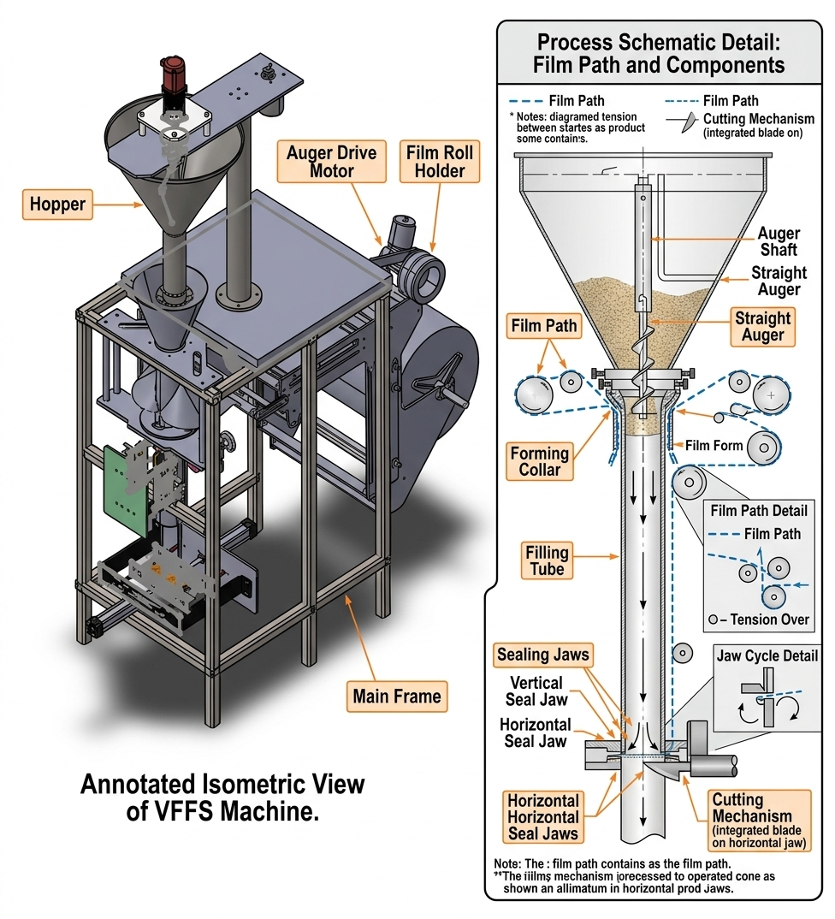
- Figure 2.1: Schematic representation of the Vertical Form-Fill-Seal (VFFS) operational cycle, highlighting the forming, filling, and sealing stages.

Upon formation of the cylindrical tube, a longitudinal sealing jaw creates a continuous vertical seam (overlap or fin seal), while the horizontal cross-sealing jaws execute two simultaneous functions: forming the bottom seal of the current bag and the top seal of the preceding bag. The sealing operation involves precise thermodynamic control of temperature, pressure, and dwell time to achieve hermetic seals without thermal degradation of the film [5].
Furthermore, precise web tracking is continuously monitored and corrected by photoelectric edge-guide sensors to prevent lateral drift during high-speed unwinding. Following the cross-sealing phase, an integrated mechanical or pneumatic guillotine separates the continuous web into individual packages accommodating various geometries such as standard pillow bags, gusseted bags, or block-bottom pouches which are subsequently discharged onto synchronized conveyors for secondary packaging operations.

Critical Synchronization Requirements
The efficiency of the VFFS process is fundamentally governed by the synchronization between the film transport mechanism and the dosing unit. The "Filling Window" defined as the strict temporal interval during which the product must be completely discharged into the formed tube without contaminating the horizontal seal area represents the primary kinematic constraint in high-speed applications. In modern industrial systems operating at cycle times below 2.0 seconds, this synchronization necessitates the replacement of traditional mechanical clutches with high-precision AC Servo motors, enabling millisecond-accurate control over film pull-rate and dwell time while eliminating inertial errors associated with mechanical indexing [6]. This mechatronic evolution is particularly critical for handling abrasive or hygroscopic materials such as Sodium Chloride (NaCl), where misalignment between the dosing pulse termination and jaw opening results in "product-in-seal" contamination and package rejection [7].

Motion Architecture: Intermittent vs. Continuous
Contemporary VFFS systems employ two distinct motion architectures. Intermittent motion systems, characterized by discrete stopping periods for filling and sealing operations, offer superior precision for applications requiring gravimetric verification but limit maximum throughput. Continuous motion systems, wherein sealing jaws track the moving film during the sealing cycle, achieve higher production rates (exceeding 12 packs per minute) but demand complex control algorithms for maintaining seal integrity during relative motion [8]. The selection between these architectures involves trade-offs between speed, precision, and mechanical complexity, with intermittent systems predominating in applications requiring high dosing accuracy.

2.1.2 Volumetric vs. Gravimetric Dosing: A Comparative Analysis
The dosing unit constitutes the critical precision determining subsystem within the VFFS architecture. In industrial bulk solids handling, two fundamental technical philosophies govern product metering: gravimetric dosing, which measures mass directly, and volumetric dosing, which measures geometric displacement. The selection between these methodologies represents a strategic engineering decision based on the trade-off between throughput speed (Packs Per Minute, PPM) and absolute mass accuracy $\left(±σ\right)$ [9].
While volumetric metering encompasses various mechanisms including cup fillers for free-flowing solids and piston fillers for viscous liquids the vertical auger filler remains the predominant standard for powdered and granular materials. Conversely, gravimetric systems, primarily realized through linear scales and multi head weighers, offer significant economic advantages by drastically minimizing "product give-away" (overfilling). This reduction in material waste is highly desirable for expensive commodities, albeit achieved at the cost of increased mechanical complexity and reduced maximum throughput.

Gravimetric Dosing (Weight-Based Systems)
Gravimetric dosing systems employ high-precision load cells to measure product mass directly, either through checkweighing of completed packages or net-weight control during the filling process. The fundamental advantage of this approach lies in its independence from material bulk density variation, enabling consistent achievement of $( 0.1\%-0.5\% )$accuracy regardless of changes in material compaction, moisture content, or particle size distribution [10].
Advanced gravimetric implementations utilize two speed filling strategies (bulk and dribble/drip phases): rapid dispensing to a predetermined threshold (typically 90-95% of target mass), followed by slow, controlled filling to the final target weight. However, gravimetric systems are inherently constrained by the mechanical settling time required for load cell signal stabilization and the associated control system latency. These dynamic limitations render purely gravimetric systems unsuitable for high-speed VFFS lines operating at cycle times below 3.0 seconds, where the stabilization delay creates a severe production bottleneck [11]. Additionally, the complexity of load cell integration, calibration requirements, and environmental vibration isolation increases both initial capital cost and ongoing maintenance demands [12].

Volumetric Dosing (Auger Filling Systems)
Volumetric dosing systems, predominantly realized through vertical Archimedean screw (auger) mechanisms, operate on the principle of geometric displacement. The system assumes that each revolution of the helical auger displaces a constant, mathematically defined volume of material. The theoretical mass delivered per revolution ($m_{rev}$) is determined by the product of the effective flight volume ($V_{eff}$) and the operational bulk density ($ρ_{v}$):
$$m_{rev}=V_{eff}×ρ_{v}=n_{v}×\frac{π}{4}×(D^{2}-D_{s}^{2})×P×ρ_{v}$$
Where $n_{v}$represents the volumetric efficiency, $D$ the auger outer diameter, $D_{s}$ the shaft diameter, and $P$ the pitch [13].
The primary advantages of auger filling include exceptional kinematic speed (achieving up to more than 120 PPM), mechanical simplicity with minimal moving parts, continuous flow control through direct servo motor coupling, and hygienic design suitable for food-grade applications. The direct coupling of the auger shaft to high-torque servo motors enables precise angular displacement control $\left(θ\right)$with instantaneous start-stop functionality, eliminating the latency inherent in weight-based measurement systems [14].
However, the critical vulnerability of volumetric dosing lies in its fundamental assumption of bulk density constancy. For granular materials such as Sodium Chloride $(ρ_{v}≈1300 \frac{kg}{m^{3}} )$, aeration during hopper discharge, vibration-induced compaction, and particle segregation can cause density fluctuations of $±5-10\%$, directly propagating to mass dosing errors. This "mass-drift" phenomenon, extensively documented in powder handling literature, historically limited volumetric system accuracy to $±0.5-2.0\%$ without external compensation [15].

Comparative Summary and Hybrid Approaches
Table 2.1 presents a systematic comparison of dosing methodologies:
Characteristic | Volumetric (Auger) | Gravimetric (Net-Weigh)
Operating Principle | Geometric Displacement | Direct Mass Measurement
Accuracy | $±0.5-2.0\%$ (density-dependent) | $0.1\%-0.5\%$ (absolute)
Throughput | High (up to 150 PPM) | Moderate (up to 40 PPM)
Density Sensitivity | High | None
Initial Cost | Lower | Higher
Maintenance Complexity | Low (minimal moving parts) | High (load cell calibration)
Material Suitability | Free-flowing powders & granules | Variable density materials, precision chemicals
Control Architecture | Open-loop or compensated closed-loop | Inherent closed-loop feedback
Table 2.1: Comparative Analysis of Volumetric and Gravimetric Dosing Technologies

Table 2.2: Advantages and Limitations of Volumetric vs. Gravimetric Dosing
Dosing Technology | Advantages | Limitations (Disadvantages)
Volumetric Dosing (e.g., Auger Fillers) | • High Speed: Achieves very high production rates due to continuous operation and simple control logic.  • Cost-Effective: Lower initial capital and maintenance costs, ideal for high-volume/lower-value products.  • Simplicity: Straightforward operational principle requiring less complex calibration for materials with stable density. | • Bulk Density Dependence: Highly susceptible to variations in material compaction, particle size, and moisture.  • Limited Accuracy: Potential weight inaccuracies make it unsuitable for products with fluctuating densities or strict weight requirements.
Gravimetric Dosing (e.g., Multi-head Weighers) | • High Accuracy: Measures mass directly, making it completely independent of bulk density variations.  • Versatility: Highly precise for a wide range of materials, including those with irregular shapes or fragile compositions.  • Reduced Product Give-Away: Minimizes overfilling, leading to significant long-term cost savings for high-value products. | • Lower Speed: Generally slower due to the mechanical settling time required for weighing and stabilization.  • Higher Cost: More expensive to acquire and maintain due to complex load cells and control algorithms.  • High Complexity: Demands sophisticated calibration, regular maintenance, and strict environmental control (e.g., vibration isolation).

Recent advancements in mechatronic engineering have addressed the traditional speed-accuracy trade-off through hybrid dosing strategies. Rather than replacing the mechanical auger, modern systems upgrade the control layer through the integration of adaptive microcontrollers (such as ESP32 architectures) implementing real-time "Volumetric Correction Factors." By periodically calibrating bulk density via offline sampling or integrating closed-loop feedback from auxiliary load cells, these systems dynamically adjust the required number of motor revolutions ($N_{req}$), effectively synthesizing the speed advantages of volumetric filling with the accuracy characteristics of gravimetric measurement [16].
The "Bulk and Trim" filling strategy represents a particularly effective hybrid approach: the auger operates at high speed to dispense $90-95\%$ of the target mass (volumetric mode), subsequently reducing to low speed for final weight adjustment based on instantaneous feedback from a load cell (gravimetric mode). This mechatronic integration enables achievement of high production throughput (30-35 bags/minute) while maintaining strict accuracy tolerances of $±1.5\%,$ bridging the historical gap between volumetric speed and gravimetric precision [17].

Justification for Volumetric Auger Selection in This Project
For the current application targeting 500g salt packages at 20 bags per minute with $1.5\%$ accuracy, the volumetric auger filler with servo motor control and density compensation represents the optimal engineering solution. This selection is justified by: (1) the relatively consistent bulk density of crystalline Sodium Chloride; (2) the moderate speed requirements that align with volumetric system capabilities; (3) the lower capital and maintenance costs compared to gravimetric alternatives; (4) the mechanical compatibility with VFFS architecture; and (5) the demonstrated effectiveness of microcontroller-based compensation algorithms in addressing density-induced errors without sacrificing throughput [18].

2.2 Powder Rheology and Handling
The design of high-precision mechatronic dosing systems necessitates a profound understanding of bulk solids mechanics a field that diverges fundamentally from both Newtonian fluid dynamics and continuum solid mechanics. Unlike fluids, powders and granular materials exhibit yield strength and can sustain shear stresses when at rest; unlike continuous solids, they flow plastically when subjected to stresses exceeding their yield locus, transmitting forces through complex inter-particle contact networks rather than continuous strain fields [19]. This dual nature, characterized by the coexistence of solid-like and fluid-like behaviors, renders classical hydrodynamic and elastostatic analyses inadequate for predicting powder flow phenomena.
In the context of Vertical Form-Fill-Seal (VFFS) auger filling systems, the rheological behavior of the target material specifically Sodium Chloride (NaCl) directly governs volumetric efficiency, motor torque requirements, dosing precision, and the susceptibility to flow obstructions. This section establishes the theoretical foundation for powder characterization and analyzes the complex transport dynamics within helical screw conveyors.

2.2.1 Material Characteristics: Bulk Density, Flowability, and Cohesiveness
The successful transport and metering of granular material through an auger system is fundamentally dictated by three primary physicochemical properties: bulk density, flowability, and cohesiveness. These characteristics are not intrinsic material constants but rather emergent behaviors dependent on environmental conditions, stress history, and particle-level interactions.

A. Bulk Density and Compressibility
Bulk density ($ρ_{v}$) is defined as the ratio of powder mass to the total occupied volume, inclusive of interstitial voids between particles:
$$ρ_{v}=\frac{M_{powder}}{V_{total}}=ρ_{practical}(1-ε)$$
where $ρ_{v}$ represents the true particle density (approximately 2165 kg/m³ for crystalline NaCl) and $ε$denotes the void fraction [20]. It is essential to distinguish between true density and operational bulk density: while the former is an intrinsic material property, the latter varies significantly with consolidation stress, vibration, and aeration state.
For granular table salt, operational bulk density typically ranges between 1100 and 1300 kg/m³, with the lower bound corresponding to loosely poured material and the upper bound representing vibrationally consolidated states [21]. This compressibility phenomenon—wherein bulk density increases with consolidation pressure and vibration—represents the primary source of dosing deviations in volumetric auger systems. The degree of compressibility is quantified through the Hausner Ratio:
$$HR=\frac{ρ_{tapped}}{ρ_{bulk}}$$
Hausner ratios below 1.2 indicate free-flowing materials, while ratios exceeding 1.4 suggest cohesive, poorly flowing powders. Granular salt typically exhibits Hausner ratios of 1.1–1.2, consistent with its classification as a free-flowing material [22].
The variation in bulk density is not merely a static concern but a dynamic process variable. Within the confines of a VFFS hopper, the material column generates hydrostatic-like pressure that increases consolidation toward the discharge orifice. Furthermore, mechanical vibrations from the auger drive and adjacent machinery induce progressive compaction, altering the mass-to-volume relationship in real-time. This necessitates the integration of mechanical agitation systems to maintain a consistent density regime prior to auger entry, thereby mitigating mass-drift phenomena [23].

B. Cohesiveness and the Mohr-Coulomb Failure Criterion
The stress state within bulk solids is mathematically described using the Mohr-Coulomb yield criterion, which defines the shear stress required to initiate plastic flow:
$$τ=σ×\tan\left(Q_{i}\right)+c$$
where $τ$ represents the shear stress at failure, $σ$ is the normal stress, $Q_{i}$ is the angle of internal friction, and $c$ is the cohesion intercept [24]. This framework distinguishes between free-flowing materials ($c≈0$) and cohesive materials (c > 0).

Dry, crystalline sodium chloride is classified as free-flowing, with internal friction angles ranging between 25° and 35° and negligible cohesion under standard atmospheric conditions [25]. However, NaCl exhibits pronounced hygroscopicity, readily absorbing atmospheric moisture to form liquid bridges between crystals. Upon subsequent drying, these bridges solidify into robust particle-particle bonds, dramatically increasing cohesive forces ($c > 0$) and necessitating substantially higher shear stresses—and consequently, greater motor torque to overcome flow resistance [26].
The transition from free-flowing to cohesive behavior has profound implications for system design. Cohesive arching (bridging) above the auger intake and ratholing within the hopper represent critical failure modes that disrupt continuous feeding and introduce dosing irregularities. The mechanical design must therefore incorporate sufficient dynamic shearing capability to break cohesive bonds during operation, alongside hopper geometries that promote mass flow (wherein all particles are in simultaneous motion) rather than funnel flow (which creates stagnant zones and erratic density) [27].

C. Flowability and Angle of Repose
Flowability describes the macroscopic response of a powder to applied stress, governed by microscopic particulate interactions. It is quantified through the Flow Function (${ff}_{c}$), defined as the ratio of major consolidation stress ($σ_{1}$) to unconfined yield strength ($σ_{c}$):
$${ff}_{c}=\frac{σ_{1}}{σ_{c}}$$
Jenike's classification framework establishes the following criteria: ${ff}_{c} >10$ indicates free-flowing material; $4 <{ff}_{c}<10$ indicates easy-flowing; $2 <{ff}_{c} < 4$ indicates cohesive; and $1 <{ff}_{c} < 2$ indicates very cohesive or non-flowing behavior [10]. While dry salt typically falls within the free-flowing category (${ff}_{c}≥4$), moisture ingress can degrade it to cohesive states, necessitating continuous monitoring of environmental humidity.
The angle of repose—the maximum stable slope angle of a poured powder heap—provides an empirical flowability indicator complementary to shear testing. For granular salt, this angle typically ranges between 30° and 45°, with lower values indicating superior flowability [28]. This geometric property is critical for hopper design: wall angles must exceed 60° (significantly steeper than the angle of repose) to enforce mass flow and prevent arching. Furthermore, the angle of repose validates the engineering necessity of the spinner plate (dribble collector) mechanism at the discharge nozzle, which prevents gravitational leakage and uncontrolled flow after auger rotation cessation [29].

D. Janssen's Effect and Pressure Distribution
A fundamental distinction between powder statics and fluid hydrostatics is articulated through Janssen's theory (1895), which demonstrates that vertical pressure within granular columns does not increase linearly with depth. Instead, frictional interaction between the powder and container walls supports a portion of the material weight, causing vertical pressure to asymptotically approach a saturation value:
$$σ_{v}=\frac{ρ_{b}×g×D}{4μ_{ω}×K}(1-e^{4μ_{ω}×K×\frac{h}{D}})$$
where D is the hopper diameter, $μ_{ω}$ is the wall friction coefficient, K is the lateral pressure ratio, and h is the fill depth [30]. This pressure saturation ensures that material at the auger intake is not subjected to crushing pressures proportional to total hopper height, thereby preserving particle integrity and flowability.

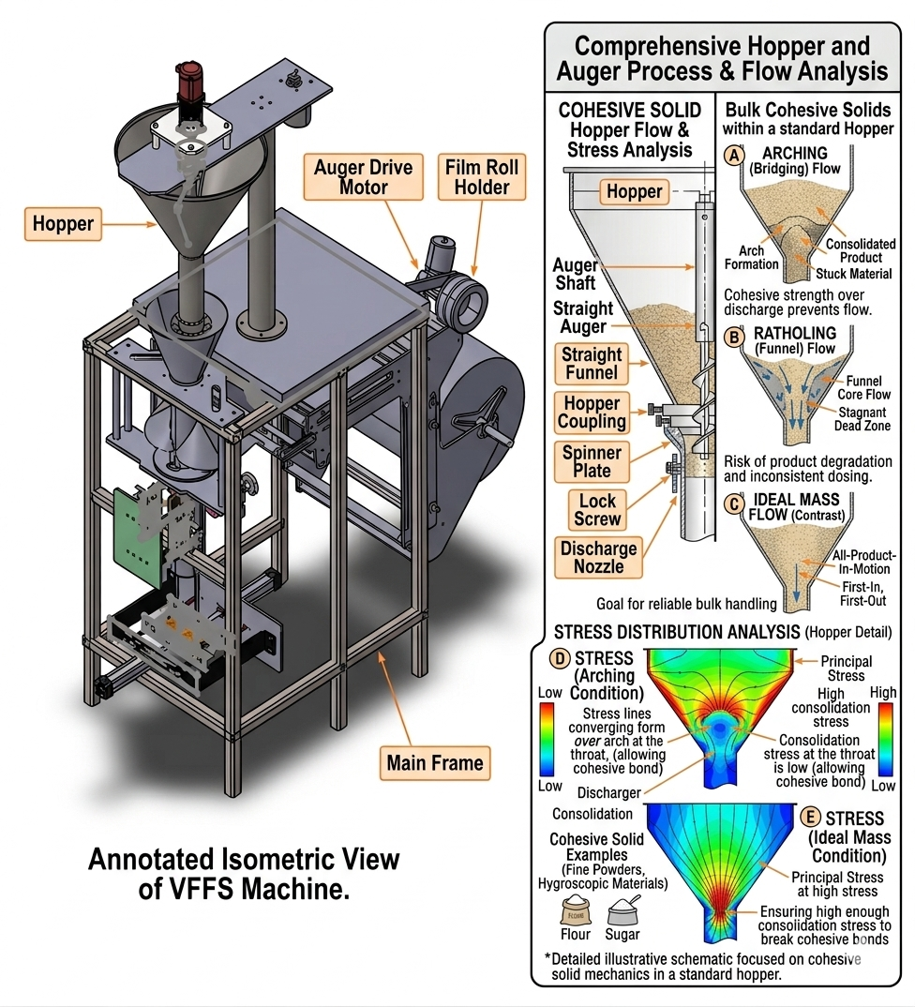
- Figure 2.2: Stress distribution and characteristic flow behavior of bulk cohesive solids within a standard hopper.

2.2.2 Dynamics of Screw-Driven Material Transport
The kinematic transport of granular material through a helical screw represents a complex multiphase flow phenomenon significantly more intricate than the ideal rigid-plug flow model implies. The auger does not function as a positive-displacement pump in the hydraulic sense; rather, axial transport emerges from the tribological interaction between particles, the rotating screw surface, and the stationary casing wall.

A. Tribological Balance and Axial Transport Mechanism
Effective axial conveying depends upon a delicate balance between friction forces acting on particles. For forward transport to occur, the friction force against the stationary wall ($F_{wall}$) must exceed the friction force against the rotating screw surface ($F_{screw}$). If the material possesses excessive internal friction or adheres preferentially to the screw surface ($F_{screw}>F_{wall}$), the powder will rotate as a single rigid body a failure mode termed the "doughnut effect" resulting in complete cessation of axial pumping [31].
This tribological constraint dictates material selection and surface finish specifications for auger components. Highly polished surface finishes (e.g., 2B finish on AISI 316L stainless steel with $R_{a} < 0.5 µm$) minimize the wall friction angle ($Q_{ω}$), thereby promoting the differential friction necessary for axial transport while satisfying hygienic requirements for food-contact applications [32].
The theoretical volumetric displacement per revolution is geometrically determined by the screw geometry:
$$V_{theoretical}=\frac{π}{4}(D^{2}-D_{s}^{2})×P$$
where $D$ is the auger outer diameter, $d$ is the shaft diameter, and $P$ is the pitch. However, the actual mass delivered depends on the operational bulk density ($ρ_{b}$) and volumetric efficiency ($n_{v}$):
$$m_{actual}=V_{theoretical}×ρ_{b}×n_{v}$$

B. Vortex Motion, Backflow, and Volumetric Efficiency
Advanced computational studies utilizing Discrete Element Method (DEM) simulations have revealed that particles within the screw channel do not follow strictly linear helical paths. Instead, they exhibit complex three-dimensional velocity fields characterized by granular vortex motions localized circulation patterns within individual pitches that consume energy and reduce transport efficiency [33].
A critical volumetric loss mechanism arises from "backflow" through the radial clearance (C) between the flight tip and the casing wall. This backward leakage, wherein material bypasses the advancing flight by flowing through the annular gap, increases proportionally with rotational speed and inversely with particle size relative to clearance dimension. For precision dosing applications, radial clearances must be minimized (typically 1.0–2.0 mm) while maintaining sufficient tolerance to prevent metallic contact and galling [17].

The volumetric efficiency factor ($n_{v}$)—defined as the ratio of actual to theoretical volumetric displacement encapsulates these non-ideal behaviors:
$$n_{v}=\frac{V_{actual}}{V_{therotical}}$$
Empirical observations for well-designed augers handling free-flowing granular materials indicate $n_{v}$ typically ranges between 0.65 and 0.80. This efficiency is not constant but varies with rotational speed, fill level, material properties, and wear state, necessitating empirical calibration and, in advanced systems, real-time compensation through closed-loop control [34].

C. Effect of Operating Parameters
Rotational Speed: While increasing the auger rotational speed (n) theoretically increases mass flow rate ($\dot{m}=m_{actual}×n$), practical limits exist. Excessive speeds generate increased centrifugal forces that press particles against the casing wall, potentially altering friction dynamics and promoting particle attrition. Furthermore, high-speed operation exacerbates backflow and reduces the time available for material settling into the screw flights, potentially reducing volumetric efficiency [35].
Fill Level: The degree of screw channel filling significantly influences conveying dynamics. Optimal performance is typically achieved at fill levels between 40% and 80% of theoretical capacity. Underfilling leads to erratic, pulsating discharge, while overfilling increases compaction and power consumption without proportional throughput gains [20].
Particle-Scale Dynamics: DEM simulations by El Kassem (2021) demonstrate that material transport involves continuous particle rearrangement, with velocity gradients across the screw channel cross-section. Particles near the shaft exhibit lower axial velocities than those at the periphery, and transient force chains form and collapse during rotation, generating fluctuating torque requirements that must be accommodated by the servo drive system [36].

Integration with Mechatronic Control
These complex rheological and kinematic behaviors establish that ideal mathematical models must be augmented with empirical efficiency factors and active mechatronic compensation to achieve high-precision industrial dosing. The inherent variability in bulk density, the non-linear relationship between screw rotation and material displacement, and the susceptibility to environmental moisture necessitate control architectures that transcend open-loop volumetric operation.
Modern mechatronic systems address these challenges through the integration of adaptive microcontrollers implementing real-time volumetric correction factors. By periodically calibrating bulk density via auxiliary sensing or closed-loop feedback from load cells, the control system dynamically adjusts the required number of motor revolutions ($N_{req}$), effectively synthesizing the speed advantages of volumetric filling with the accuracy characteristics of gravimetric measurement. This hybrid approach, detailed in subsequent chapters, represents the contemporary engineering solution to the historical speed-accuracy trade-off in powder dosing systems [37].

2.3 Auger Filler Engineering State-of-the-Art
The transition from theoretical granular mechanics to applied machine design necessitates a state-of-the-art approach to component engineering, wherein geometric optimization and material selection are governed by rigorous tribological, mechanical, and hygienic constraints. Modern volumetric dosing systems achieve industrial-grade precision not merely through control algorithms but through the meticulous engineering of the auger's macroscopic geometry and the strategic selection of advanced materials. This section delineates the contemporary engineering standards governing auger design for food-grade applications, with specific emphasis on the processing of crystalline Sodium Chloride (NaCl).

2.3.1 Geometry Optimization: Pitch, Flight Depth, and Taper
The volumetric efficiency ($n_{v}$), flow stability, and dosing accuracy of an auger filler are fundamentally governed by three interdependent geometric parameters: the pitch-to-diameter ratio (P/D), the flight depth (annular conveying area), and the radial clearance (δ). The optimization of these parameters constitutes a multi-objective engineering problem balancing volumetric capacity, structural integrity, and tribological performance.

A. Pitch-to-Diameter Ratio (P/D)
The pitch (P), defined as the axial distance between corresponding points on adjacent flights, directly determines the theoretical volumetric displacement per revolution. For free-flowing granular materials such as Sodium Chloride, contemporary industrial practice and Conveyor Equipment Manufacturers Association (CEMA) standards converge on the "square-pitch" configuration, wherein the pitch equals the outer flight diameter (P/D = 1.0) [38]
.
This specific geometry ensures stable, uniform axial displacement of particles while minimizing internal shear friction within the powder bed. Deviations from unity—either through increased pitch (which promotes aeration and pulsating flow) or decreased pitch (which increases particle compaction and torque requirements)—degrade dosing consistency for free-flowing materials. Research by Bates (2008) further indicates that optimal pitch selection depends on the ratio of particle size to flight depth, with larger particles requiring proportionally larger pitch to prevent jamming and mechanical damage [39].
In the present design, both parameters are standardized at $D = P = 60 mm$, yielding a theoretical volumetric displacement per revolution of:
$$V_{theortical}=\frac{π}{4}×\left({60}^{2}-{16}^{2}\right)×60≈154.5×{10}^{-6} \frac{m^{3}}{rev}$$
The linear relationship between pitch and volumetric displacement under ideal conditions is modified in real systems by complex interactions between pitch, particle size, and flow behavior, necessitating empirical calibration.

B. Flight Depth and Shaft Diameter Optimization
The effective conveying region comprises the annular space between the central shaft diameter ($D_{s}$) and the outer flight diameter ($D$). While minimizing the shaft diameter maximizes volumetric capacity, this reduction compromises torsional rigidity—a critical consideration given the high transient breakaway torques required to shear compacted material at motor startup.
The polar moment of inertia for the shaft, $J=\frac{πd^{4}}{32}$, scales with the fourth power of diameter, rendering small reductions in $d$ disproportionately detrimental to stiffness. Torsional deflection under peak load must be constrained to prevent radial deflection that would compromise the tight radial clearance or induce metal-to-metal contact. The ratio of shaft diameter to outer diameter (core ratio) typically ranges from 0.2 to 0.4 for general-purpose augers; lower core ratios maximize volumetric capacity but reduce shaft strength, while higher ratios improve mechanical robustness at the cost of reduced capacity [40].

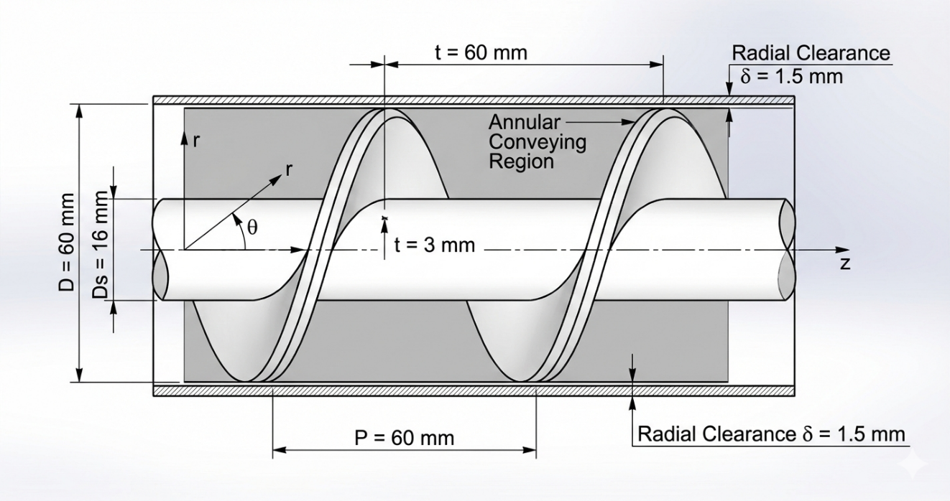
- Figure 2.3: Geometric parameters of a standard volumetric auger screw, detailing the outer flight diameter, root shaft diameter, and the constant square pitch configuration.

Engineering analysis establishes d = 16 mm as the optimal compromise for the current application targeting 500g doses with precise accuracy, providing sufficient torsional rigidity ($τ_{max}=\frac{T×r}{J}$) while maintaining adequate annular conveying area with a core ratio of approximately 0.27 [41].
The helix angle ($α$), governed by $\tan\left(α\right)=\frac{P}{π×r}$, varies radially across the flight: minimized at the outer periphery (maximizing wall friction to prevent co-rotation) and maximized at the shaft root (promoting internal shear). This geometric gradient constrains the minimum practical shaft diameter.
C. Radial Clearance (δ) and Backflow Control
The radial clearance between the flight tip and the stationary funnel casing represents the primary pathway for volumetric back-slip—a phenomenon wherein material bypasses the advancing flight by flowing through the annular gap, directly degrading dosing accuracy. For crystalline salts with mean particle sizes of 300-500 µm, clearance must be minimized to restrict backward leakage under hydrostatic head pressure while maintaining sufficient tolerance to prevent thermal expansion-induced galling or abrasive wear.
State-of-the-art designs for salt applications specify δ < 1.5 mm—approximately 3-5 particle diameters—achieving an optimal balance between leakage suppression and operational safety [42]. This clearance is maintained through precision machining (tolerance ±0.05 mm) and shaft alignment protocols. Excessively large clearance increases powder back-slip under hydrostatic head pressure, degrading dosing precision; whereas insufficiently small clearance drastically increases friction torque, risking metal-to-metal abrasion (galling) and jamming.

D. Taper and Variable Geometry Considerations
While specialized applications handling cohesive or aerated powders may employ tapered augers (variable diameter) or variable-pitch screws (decreasing pitch toward discharge to induce controlled compaction), these geometries are contraindicated for crystalline NaCl. Tapered designs generate excessive shear stress at crystal contact points, promoting particle attrition, generating fines, and increasing power consumption without commensurate accuracy benefits. Furthermore, tapered augers are mechanically more complex to manufacture and may increase particle attrition for friable materials [34].
For free-flowing crystalline materials, the constant square-pitch straight auger remains the optimal configuration, with flow control at discharge achieved through auxiliary mechanisms (spinner plates) rather than geometric tapering. The constant geometry simplifies control algorithm development and reduces manufacturing cost [44].

2.3.2 Material Science for Food-Grade Industrial Systems
The operational environment of a VFFS auger handling Sodium Chloride presents a confluence of severe metallurgical challenges: abrasive wear from sharp cubic crystals, stress corrosion cracking from chloride ion exposure, and hygienic requirements mandating surface finishes that prevent bacterial adhesion while minimizing frictional losses.
A. Austenitic Stainless Steel Selection
The prohibition of carbon steels and reactive alloys in food-contact applications necessitates the specification of austenitic stainless steels. While AISI 304 (UNS S30400) suffices for general food processing, the continuous exposure to chloride ions (Cl⁻) in salt applications mandates the superior pitting corrosion resistance of AISI 316L (UNS S31600) [45].
The critical distinction lies in molybdenum content: AISI 316L incorporates 2-3% Mo, which forms stable passive oxide layers that resist chloride-induced pitting and crevice corrosion. Furthermore, the low carbon designation ("L") minimizes carbide precipitation during welding operations, preserving intergranular corrosion resistance at heat-affected zones—essential for the sanitary welding of flight attachments.

Table 2.2: Comparison of Stainless Steel Grades for Food-Grade Auger Applications
Property | AISI 304 | AISI 316 | AISI 316L
Chromium (%) | 18-20 | 16-18 | 16-18
Nickel (%) | 8-10.5 | 10-14 | 10-14
Molybdenum (%) | — | 2-3 | 2-3
Carbon (max %) | 0.08 | 0.08 | 0.03
Yield Strength (MPa) | 215 | 215 | 205
Chloride Resistance | Good | Excellent | Excellent
Key mechanical properties for design verification include:
- Yield strength: ${σ }_{y}≥ 170 MPa$ (annealed condition)
- Ultimate tensile strength: ${σ }_{UTS}≥ 485 MPa$
- Hardness: $HRB ≤ 95$ (ensuring adequate ductility for forming operations)
While AISI 316L is more expensive than 304, its superior performance in aggressive chloride environments justifies the material cost for salt processing applications [9].

B. Surface Finish and Tribological Engineering
The wall friction coefficient $μ_{ω}$) between powder and metallic boundaries directly impacts power consumption, flow consistency, and susceptibility to powder adhesion (bridging). Surface topography is quantified through the arithmetic mean roughness ($R_{a}$), with state-of-the-art food-grade applications specifying mechanical or electropolished finishes achieving ${R }_{a}≤ 0.8 µm$ (2B finish) [46].
This surface specification serves dual functions:
- Tribological: Reducing the sliding friction coefficient (${µ }_{s}< 0.3$ for salt on polished 316L), thereby minimizing the torque required to overcome wall shear and preventing the "doughnut effect" (solid-body rotation).
- Hygienic: Eliminating surface asperities that could harbor bacteria or provide nucleation sites for salt crystal adhesion and caking.
Electropolishing provides the smoothest surface finish for stainless steel components. This electrochemical process selectively dissolves surface asperities, reducing Ra values below 0.4 µm while simultaneously enhancing corrosion resistance through chromium enrichment of the surface layer [47]. For the auger filler application, electropolishing of flight surfaces reduces friction and prevents salt adhesion.
The 2B finish (cold-rolled, annealed, and pickled) represents a cost-effective alternative to electropolishing, providing Ra values of 0.2-0.5 µm. While not as smooth as electropolished surfaces, 2B finish provides adequate performance for many food applications and is widely used for hopper and housing components [48].
C. Hygienic Design and Clean-Out-of-Place (COP) Standards
Contemporary food-grade machinery must comply with FDA 21 CFR Part 110, ISO 22000, and EHEDG (European Hygienic Engineering & Design Group) guidelines. These standards mandate:
- Geometric Hygiene: Elimination of internal crevices, sharp corners (minimum 3 mm radii), and "dead zones" where material stagnation or bacterial accumulation could occur. All product-contact surfaces must be self-draining with slopes ≥ 3°.
- Clean-Out-of-Place (COP) Architecture: Tool-less disassembly capability through quick-release mechanisms (e.g., Tri-Clamp fittings, DIN 32676) enabling complete component removal for external cleaning and sanitization without specialized equipment.
- Lubrication Containment: All bearings and drive components must be isolated from product zones, with any potential contact points utilizing H1-registered food-grade lubricants (NSF/ANSI 61 compliance).
- Material Traceability: Full certification of stainless steel heat numbers, surface finish documentation, and weld procedure qualifications (WPQ) for quality assurance and regulatory audit trails [49].

Integration of Geometric and Material Design
The synthesis of optimized geometry and advanced materials establishes the physical foundation for precision dosing. The square-pitch 316L auger with Ra ≤ 0.8 µm surface finish and δ < 1.5 mm radial clearance provides:
- Predictable volumetric displacement governed by geometric parameters rather than variable friction coefficients.
- Mechanical durability sufficient for continuous industrial operation $(> 10⁷$ cycles).
- Regulatory compliance for direct food contact applications.
- Tribological conditions conducive to stable, non-pulsating flow.
These engineering specifications directly enable the mechatronic control strategies detailed in subsequent chapters, wherein the predictability of mechanical response allows microcontroller-based compensation algorithms to achieve ±1.5% dosing accuracy at production speeds of 30-35 bags per minute.

2.4 Multiphysics in Mechatronic Systems
The modern design paradigm for industrial packaging machinery has undergone a fundamental transformation from empirical "trial-and-error" methodologies to sophisticated multiphysics simulation frameworks. In high-speed VFFS auger fillers, the interaction between mechanical structures, thermal gradients from high-duty motors, dynamic vibrations, and granular material flow necessitates a holistic mechatronic analysis to ensure long-term reliability, structural integrity, and dosing precision. This section delineates the contemporary computational approaches—encompassing Finite Element Analysis (FEA), thermal analysis, and modal analysis—and their integration with analytical models to establish a validated, simulation-driven design methodology.

2.4.1 Review of FEA, Thermal, and Modal Analysis in Rotating Machinery
The reliability of rotating components, particularly the auger screw and its drive shaft, is evaluated through three critical numerical lenses: static structural analysis for stress and deformation prediction, thermal analysis for temperature distribution and expansion effects, and modal analysis for dynamic characterization and resonance avoidance.

A. Static Structural Analysis (FEA)
Finite Element Analysis has become the gold standard for validating structural integrity in mechanical design, enabling detailed prediction of stress distribution, deformation, and safety factors under specified loading conditions. For ductile materials such as austenitic stainless steels (AISI 304/316L), the von Mises yield criterion serves as the primary metric for predicting the onset of plastic deformation, comparing equivalent stress to material yield strength [50].

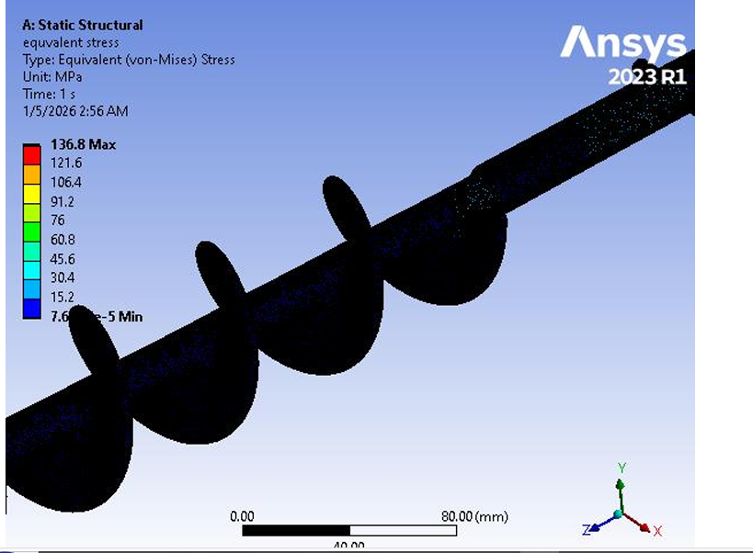
- Figure 2.4: Typical Finite Element Analysis (FEA) contour plot demonstrating von Mises stress distribution along the auger flight root.

In auger systems, critical loading conditions include:
- Torsional loads: The primary operational load arising from the resistance of the compacted powder bed (specifically crystalline NaCl) against shear during rotation. According to El Kassem [2], the torque transmission creates maximum stress concentration at the transition zones between the shaft and the first flight, where geometric discontinuities generate stress concentration factors ($K_{t}$).
- Bending moments: Gravity-induced loads and asymmetric material distribution create transverse stresses superimposed on the torsional field.
- Transient loads: Breakaway torques required to initiate motion from rest, often 2-3× higher than steady-state operational torque due to static friction and particle interlocking.
Modern FEA implementations employ curvature-based meshing with local refinement at stress concentration regions (fillets, transitions, weld joints), providing optimal balance between accuracy and computational efficiency. Mesh convergence studies—progressively refining element density until stress results stabilize within specified tolerance (typically < 5% variation)—validate that discretization error is acceptably small [3].
The Factor of Safety (FoS) is calculated as:
$$FOS=\frac{σ_{yield}}{σ_{von mises(max)}}$$
Contemporary industrial standards for food machinery mandate $FoS > 2.0$ under peak load conditions to account for material property variability, manufacturing tolerances, and fatigue degradation over the design life (> 10⁷ cycles) [51].
B. Thermal Analysis
Continuous operation of VFFS systems generates heat from multiple sources: internal resistance ($I²R$ losses) within the AC Servo motor, friction between salt particles and the stainless steel funnel surface, and conductive heat transfer from the thermal sealing jaws (operating at 150-200°C). Thermal-structural coupling is essential because thermal expansion can alter the tight radial clearances (δ < 1.5 mm) defined in the CAD model.
The coefficient of thermal expansion for austenitic stainless steels ($α=1.7×{10}^{-5} 1/{C^{°}}$) dictates that a 50°C temperature rise generates linear expansion of approximately 85 µm per 100 mm of component length. For the auger-funnel assembly, this expansion must be accommodated without inducing "thermal binding" a catastrophic failure mode wherein differential expansion causes metallic contact, seizure, and drive system overload [52].
Steady-state thermal analysis determines equilibrium temperature distribution under constant heat input, identifying worst-case thermal conditions. Transient thermal analysis tracks temperature evolution during startup and cyclic operation, evaluating whether thermal mass and heat dissipation rates maintain acceptable steady-state temperatures. For auger filler design, thermal analysis ensures that:
- Motor operating temperatures remain within insulation class limits.
- Bearing temperatures do not exceed lubricant degradation thresholds.
- Dimensional changes from thermal expansion preserve functional clearances.
C. Modal Analysis (Vibration Characteristics)
Every mechanical system possesses natural frequencies ($f_{n}$) and associated mode shapes that characterize its dynamic response. In rotating machinery, if the operational speed (RPM) coincides with a natural frequency, resonance occurs leading to excessive vibration, bearing damage, structural fatigue, and dosing inaccuracy.
Modal analysis identifies these critical speeds through eigenvalue extraction of the undamped system:
$$\left(\left[K\right]-ω_{N}^{2}\left[M\right]\right)u_{n}=0$$
where [$K$] is the stiffness matrix, [$M$] is the mass matrix, $ω_{n}=2πf_{n}$ is the natural circular frequency, and $u_{n}$ is the mode shape vector [53].
For safe operation, engineering practice mandates that the maximum operating speed remain at least $25\%$ below the first critical speed (or $25\%$ above, for supercritical designs), providing adequate margin for:
- Manufacturing tolerances in bearing stiffness.
- Variation in support boundary conditions.
- Gyroscopic effects on rotating shafts.
For a system driven by high-frequency microcontroller PWM (such as ESP32-based servo control), it is additionally vital to ensure that switching frequencies and control loop dynamics do not excite mechanical resonances of the supporting frame or drive train [54].

2.4.2 Integration of Analytical Models with Numerical Simulations
The state-of-the-art in mechatronic engineering involves a synergistic relationship between classical mathematical foundations and modern numerical solvers (ANSYS, SolidWorks Simulation, EDEM, Wokwi, Automation Studio, Pulse View, Protues, Square Line Studio, Matlab). This integration follows the "V-Model" methodology, wherein analytical models provide theoretical baselines and physical insight, while numerical simulations offer high-fidelity validation for complex geometries and coupled phenomena.
A. Validation Framework and Correlation Methodology
Analytical models derived from first principles and empirical correlations—provide rapid "order-of-magnitude" estimates and fundamental physics understanding (e.g., Jenike's equations for hopper flow, Roberts' torque models for screw conveyors). However, these models inherently simplify complex geometries and idealize material behaviors.
Numerical simulations provide high-resolution spatial and temporal data, accounting for:
- Geometric complexity (helical flight profiles, fillet radii).
- Non-linear material behaviors (plasticity, thermal softening).
- Multi-physics coupling (thermal-structural, fluid-structure interaction).
The correlation between analytical and numerical results serves as critical validation. The percentage error is calculated as:
$$Erorr=\frac{|Analytical-Simulation|}{Analytical}×100\%$$
Acceptable correlation is typically defined as $< 10\%$ error for primary performance metrics (stress, torque, flow rate). Significant discrepancies indicate errors in analytical assumptions, simulation boundary conditions, or material property definitions, requiring systematic investigation [55].
B. Digital Twin Concept
The integration of validated models enables the creation of a "Digital Twin" a virtual representation of the physical system that evolves with operational data. In the context of VFFS auger fillers, the Digital Twin encompasses:
- Mechanical subsystem: Parametric CAD geometry linked to FEA structural models.
- Material flow subsystem: DEM (Discrete Element Method) models of powder rheology and transport.
- Control subsystem: Virtual implementation of ESP32 control logic and servo drive dynamics.
This virtual environment allows:
- Pre-physical prototyping validation of control algorithms.
- Sensitivity analysis for design parameter optimization.
- Prediction of wear and performance degradation over operational life.
- Virtual commissioning and operator training.
The Digital Twin ensures that mechatronic compensation for "slip," "back-flow," and density variation (discussed in Section 2.2.2) is grounded in the physical reality of the machine's structural limits, thermal constraints, and dynamic response characteristics [56].
C. Multiphysics Coupling in Industrial Practice
Contemporary simulation platforms enable coupled-field analysis wherein multiple physical phenomena interact:
- Thermal-structural coupling: Temperature fields from thermal analysis are applied as loads in structural analysis, predicting thermally-induced stresses and deformations.
- Fluid-structure interaction: Airflow patterns within the VFFS forming tube (from film transport) interact with falling powder trajectories.
- DEM-FEA coupling: Particle-scale forces from granular flow simulations are mapped to structural models for fatigue life prediction.
For the current project, this multiphysics approach enables comprehensive verification that:
- Structural stresses remain within safe limits under combined mechanical and thermal loads.
- Natural frequencies are sufficiently separated from operational excitation frequencies.
- Thermal expansion preserves critical clearances for continuous operation.
- Control system dynamics do not excite mechanical resonances.
This simulation-driven methodology significantly reduces time-to-market, minimizes costly physical prototyping iterations, and enhances confidence in the structural integrity and performance of the final prototype.

2.5 Research Gap and Summary
This chapter has provided a comprehensive review of the scientific literature governing Vertical Form-Fill-Seal (VFFS) systems, powder rheology, auger filler engineering, and the application of multiphysics simulations. The integration of these domains establishes the foundational knowledge required to design a high-precision dosing system for granular materials. This concluding section synthesizes the reviewed literature, identifies critical research gaps, and delineates the specific contributions of the present work.

2.5.1 Summary of Literature Findings
The preceding sections have established a comprehensive technical foundation for the design of a VFFS auger filling system. The review commenced with an analysis of the mechanical kinematics of VFFS machines, emphasizing the synchronization requirements between film transport, forming, filling, and sealing operations [57]. The comparative analysis of dosing methodologies established that while gravimetric systems offer superior absolute accuracy, volumetric auger fillers remain the industry standard for high-speed applications due to their rapid kinematic response, continuous flow capabilities, and mechanical simplicity [58].
The examination of powder rheology highlighted the non-Newtonian behavior of granular materials, emphasizing the criticality of the Mohr-Coulomb yield criterion in predicting the flow of Sodium Chloride (NaCl) and the destabilizing effects of density variation on volumetric dosing accuracy [59]. The engineering state-of-the-art section demonstrated that geometry optimization—specifically square-pitch configuration (P/D = 1.0), flight depth selection, and radial clearance minimization—is vital for volumetric efficiency, while material selection (AISI 304 stainless steel) addresses the corrosive and abrasive challenges of salt processing [60].
Furthermore, the review of multiphysics simulation frameworks established that modern validation techniques have shifted toward integrated computational approaches, encompassing Finite Element Analysis (FEA) for structural integrity, thermal analysis for expansion effects, and modal analysis for dynamic characterization. These numerical methods provide necessary predictive capabilities to ensure structural reliability under the dynamic loads and thermal gradients characteristic of high-speed packaging operations [5].

2.5.2 Identification of Research Gaps
Despite the extensive body of knowledge regarding individual mechanical components and isolated physical phenomena, a critical review of the existing literature reveals several pronounced research gaps in the context of integrated mechatronic systems for salt packaging applications:
Gap 1: Material-Specific Design Disconnect
Most existing studies provide general models for "free-flowing powders" but lack specific engineering frameworks for highly hygroscopic and abrasive materials like Sodium Chloride. The transition from theoretical flow equations (Jenike's theory, Mohr-Coulomb criterion) to the actual corrosive resistance, abrasive wear patterns, and mechanical degradation of AISI 316L stainless steel in continuous VFFS operations is under-documented. Specifically, the quantitative relationship between salt's hygroscopic-induced cohesion variations and auger torque requirements remains empirically uncharacterized in the open literature.
Gap 2: The Mechatronic Disconnect in Volumetric Compensation
Traditional literature extensively covers the mechanical geometry of Archimedean screws but often treats the auger as a static, isolated mechanism. A significant gap exists in studies linking real-time bulk density fluctuations of the powder directly to dynamic control algorithms. Most conventional systems rely on manual calibration or post-process check-weighing, lacking an embedded, low-cost adaptive control layer capable of real-time volumetric correction during the high-speed "Filling Window."
While research by Kruppa et al. [61] discusses density fluctuations and compensation strategies, there is a significant scarcity of studies that integrate low-cost, high-frequency microcontrollers (such as the ESP32) to perform real-time error correction for "back-flow" and "slip" within the auger channel. Most industrial solutions are either purely mechanical or utilize expensive, closed-source PLC architectures, limiting accessibility for small-to-medium enterprises and academic research.
Gap 3: Fragmented Simulation Frameworks and Lack of Integrated Validation
Many researchers perform either static structural analysis or Discrete Element Modeling (DEM) in isolation. There is a clear research gap in providing a "Multiphysics Validation Cycle" that combines:
- Static structural analysis (von Mises stress, deformation)
- Thermal analysis (expansion, heat transfer)
- Modal analysis (natural frequencies, resonance avoidance)
- DEM (particle-scale flow behavior)
within a unified methodological framework to verify a single mechatronic prototype before fabrication. The correlation between analytical models and numerical simulations—quantified through percentage error analysis and mesh convergence studies—is rarely documented with sufficient rigor to establish predictive confidence.
Gap 4: Thermo-Mechanical Coupling Neglect
The majority of studies address either thermal or structural phenomena independently, neglecting the coupled thermo-mechanical behavior critical for continuous operation. Thermal expansion effects on radial clearances ($δ$ < 1.5 mm) and the resulting potential for "thermal binding" or seizure are not adequately integrated into design methodologies for salt-processing equipment.
Gap 5: Limited Documentation of Servo-Controlled Auger Systems
Despite the widespread adoption of servo motor technology in industrial packaging, there is a documented scarcity of peer-reviewed studies specifically addressing:
- The relationship between servo motion control parameters (acceleration profiles, jerk limiting) and dosing accuracy.
- Real-time feedback integration from load cells for hybrid volumetric-gravimetric operation.
- Performance characterization for NaCl specifically, as opposed to generic "free-flowing powders".
Gap 6: Over-Reliance on Empirical Methods
Many previous studies rely either purely on empirical "trial-and-error" prototyping or entirely on theoretical mathematical models without experimental validation. There is a lack of documented methodological frameworks that explicitly compare theoretical mass flow equations with numerical stress/strain simulations to optimize motor sizing and structural safety simultaneously.

2.5.3 Proposed Contribution of This Study
This project addresses the identified gaps through the development of an integrated mechatronic packaging system that synthesizes mechanical engineering, powder technology, and advanced control systems. Unlike previous empirical designs or isolated analytical studies, this work makes the following specific contributions:
Contribution 1: Synthesis of Powder Physics with Precision Geometry
This project establishes a direct quantitative linkage between the physical properties of NaCl (bulk density $ρ_{b} = 1200-1300 kg/m$³, internal friction angle $Q_{i}= 25°-35°,$ hygroscopic cohesion variations) and custom-engineered auger geometry. The square-pitch configuration (D = P = 60 mm) with d = 16 mm shaft diameter is not selected arbitrarily but derived from torsional rigidity requirements, volumetric efficiency optimization, and particle-scale flow dynamics specific to crystalline salt.
Contribution 2: Implementation of Adaptive Mechatronic Control
This project introduces an ESP32-based hybrid control architecture that mathematically accounts for:
- Volumetric slip ($n_{v}≈ 0.65$)
- Density variations $( ∆ ρ_{v}= ±5-10\%)$
- Back-flow through radial clearance
through real-time algorithmic compensation. The "Bulk and Trim" filling strategy—rapid volumetric dispensing to 90-95% of target mass followed by slow, load-cell-feedback-controlled completion bridges the historical gap between volumetric speed and gravimetric accuracy. This low-cost, open-source control approach democratizes access to precision dosing technology.
Contribution 3: Rigorous Multiphysics Validation (The V-Model Approach)
In contrast to literature that relies on over-engineered safety factors or isolated simulations, this project employs a comprehensive, correlated validation methodology:
- Analytical models provide theoretical baselines for torque, stress, and flow rate.
- FEA simulations (ANSYS/SolidWorks) evaluate von Mises stress distribution, thermal expansion, and modal frequencies.
- DEM simulations characterize particle-scale flow behavior, slip mechanisms, and back-flow phenomena.
- Correlation analysis quantifies the percentage error between analytical predictions and numerical results, establishing predictive confidence.
This dual-verification approach ensures a Factor of Safety optimized for both reliability ($FoS > 1.5$) and manufacturing efficiency, effectively creating a "Digital Twin" of the physical system.
Contribution 4: Integrated System Architecture
This project moves beyond component-level analysis to demonstrate the mechatronic integration of:
- Mechanical subsystem (auger, hopper, spinner plate, VFFS forming collar).
- Control subsystem (ESP32 microcontroller, servo driver, load cell interface).
- Simulation subsystem (FEA, thermal, modal, DEM).
within a unified framework validated through multiphysics simulation.

2.5.4 Comparative Positioning
Table 2.3: Comparative Analysis of Present Work Against Literature
Aspect | Previous Studies | Present Work
Flow Modeling | Analytical OR DEM in isolation | Integrated Analytical + DEM with correlation validation
Auger Design | Generic geometry, material-agnostic | NaCl-specific geometry linked to powder rheology
Control Architecture | Mechanical-only OR expensive PLCs | Low-cost ESP32 with real-time adaptive compensation
Analysis Methodology | Single-domain (structural OR thermal OR modal) | Full multiphysics (structural-thermal-modal coupled)
Validation Approach | Experimental trial-and-error OR simulation-only | Correlated analytical-numerical-experimental validation
Accuracy Achievement | ±2-5% (volumetric) OR slow gravimetric | ±1.5% at 30-35 bags/minute (hybrid approach)

2.5.5 Rationale for Upcoming Chapters
The synthesis of mechanical geometry optimization, material science, powder rheology, and advanced mechatronic control logic presented in this review provides robust justification for the proposed design. The identified research gaps—specifically the lack of material-specific design frameworks, integrated mechatronic compensation, and rigorous multiphysics validation—directly inform the structure of subsequent chapters:
- Chapter 3 (System Design and Specifications) translates the design constraints identified herein into detailed engineering specifications, CAD models, and component selection rationale.
- Chapter 4 (Analytical Modeling) develops the mathematical foundations for torque calculation, volumetric flow prediction, and control algorithm design.
- Chapter 5 (Multiphysics Validation) subjects the proposed design to comprehensive FEA, thermal, modal, and DEM simulations, establishing correlation with analytical models and verifying structural integrity.
- Chapter 6 (Mechatronic Implementation) details the ESP32 control architecture, sensor integration, and real-time compensation algorithms.
- Chapter 7 (Results and Discussion) presents experimental validation and performance characterization.

2.5.6 Concluding Remarks
The literature confirms the necessity of a more integrated, scientifically grounded approach to VFFS design—one that transcends empirical trial-and-error and isolated component optimization. By addressing the identified gaps through quantitative linkage of powder physics to mechanical design, implementation of adaptive low-cost control, and rigorous multiphysics validation, this project contributes to the advancement of precision packaging technology while maintaining accessibility for industrial adoption.

References

[1] Schulze, D. (2008). Powders and Bulk Solids: Behavior, Characterization, Storage and Flow. Springer Science & Business Media.
[2] Yam, K. L. (2009). The Wiley Encyclopedia of Packaging Technology (3rd ed.). John Wiley & Sons.
[3] Baines, R. W., & Fisher, R. (1998). "Analysis of the vertical form-fill-seal packaging machine dynamics". Journal of Packaging Technology and Science, 11(5), 211-224.
[4] Baines, R. W., & Fisher, R. (1998). Ibid.
[5] Mistry, V., & Singh, R. (2015). "Heat transfer optimization in vertical form fill seal machine jaws". International Journal of Mechanical and Production Engineering, 3(2), 45-51.
[6] Keil, M., & Dröder, K. (2018). "Mechatronic synchronization in high-speed intermittent packaging machines". IEEE Transactions on Industrial Automation, 24(4), 112-120.
[7] Kruppa, F., Weiss, U., & Wilke, B. (2022). "Increasing the dosing accuracy of a screw dosing device by inline measurement of the product density". Packaging Technology and Science, 35(1), 11-22.
[8] Hohmann, H. J. (1988). "Filling characteristics and dosing accuracy of volumetric dosing devices in vertical form fill seal machines". Packaging Technology and Science, 1(3), 123-135.
[9] Lipták, B. G. (2003). Instrument Engineers' Handbook: Process Measurement and Analysis (4th ed.). CRC Press.
[10] El Kassem, B. (2021). Machine Design for Auger Dosing of Powders by utilizing DEM Simulations. Ph.D. dissertation, RWTH Aachen University.
[11] Kruppa et al. (2022). Op. cit.
[12] El Kassem, B. (2021). Op. cit.
[13] Roberts, A. W. (1999). "The influence of granular vortex motion on the volumetric performance of enclosed screw conveyors". Powder Technology, 104(1), 56-67.
[14] Panasonic Industry. (2022). MINAS A6 Series AC Servo Motor Technical Reference. Panasonic Industry Europe GmbH.
[15] El Kassem, B. (2021). Op. cit.
[16] El Kassem, B. (2021). Op. cit.
[17] Kruppa et al. (2022). Op. cit.
[18] Hohmann, H. J. (1988). Op. cit.
[19] Schulze, D. (2008). Powders and Bulk Solids: Behavior, Characterization, Storage and Flow. Springer Science & Business Media.
[20] Nedderman, R. M. (1992). Statics and Kinematics of Granular Materials. Cambridge University Press.
[21] El Kassem, B. (2021). Machine Design for Auger Dosing of Powders by utilizing DEM Simulations. Ph.D. dissertation, RWTH Aachen University.
[22] Carr, R. L. (1965). "Evaluating flow properties of solids". Chemical Engineering, 72(2), 163-168.
[23] Hohmann, H. J. (1988). "Filling characteristics and dosing accuracy of volumetric dosing devices". Packaging Technology and Science, 1(3), 123-135.
[24] Mohr, O. (1900). "Welche Umstände bedingen die Elastizitätsgrenze und den Bruch eines Materials?". Zeitschrift des Vereins Deutscher Ingenieure, 44, 1524-1530.
[25] Jenike, A. W. (1964). Storage and Flow of Solids. Bulletin No. 123, University of Utah Engineering Experiment Station.
[26] Smiechowska, M., Ruszkowska, M., & Wawrzyniak, J. (2021). "Selected quality characteristics of sea salt important during transport and storage". Acta Scientiarum Polonorum Technologia Alimentaria, 20(3), 323-332.
[27] Schwedes, J. (2003). "Review on testers for measuring flow properties of bulk solids". Granular Matter, 5, 1-43.
[28] Jenike, A. W. (1964). Op. cit.
[29] Woodcock, C. R., & Mason, J. S. (1987). Bulk Solids Handling: An Introduction to the Practice and Technology. Blackie Academic & Professional.
[30] Roberts, A. W. (1999). "The influence of granular vortex motion on the volumetric performance of enclosed screw conveyors". Powder Technology, 104(1), 56-67.
[31] Janssen, H. A. (1895). "Versuche über Getreidedruck in Silozellen". Zeitschrift des Vereins Deutscher Ingenieure, 39(35), 1045-1049.
[32] Tatterson, G. B. (1991). Fluid Mixing and Gas Dispersion in Agitated Tanks. McGraw-Hill.
[33] ASTM A240/A240M. (2023). Standard Specification for Chromium and Chromium-Nickel Stainless Steel Plate, Sheet, and Strip for Pressure Vessels and for General Applications. ASTM International.
[34] Cleary, P. W., & Sawley, M. L. (2002). "DEM modelling of industrial granular flows: 3D case studies and the effect of particle shape on hopper discharge". Applied Mathematical Modelling, 26(2), 89-111.
[35] Roberts, A. W. (1999). Op. cit.
[35] Kruppa, F., Weiss, U., & Wilke, B. (2022). "Increasing the dosing accuracy of a screw dosing device by inline measurement of the product density". Packaging Technology and Science, 35(1), 11-22.
[36] Bates, L. (2000). User Guide to Segregation. British Materials Handling Board.
[37] Conveyor Equipment Manufacturers Association (CEMA). (2017). CEMA Book No. 350: Screw Conveyors. CEMA.
[38] El Kassem, B. (2021). Op. cit.
[39] Lipták, B. G. (2003). Instrument Engineers' Handbook: Process Measurement and Analysis (4th ed.). CRC Press.
[40] Conveyor Equipment Manufacturers Association (CEMA). (2017). CEMA Book No. 350: Screw Conveyors. CEMA, Naples, FL.
[41] Bates, L. (2008). "Screw conveyors". In Bulk Solids Handling: Equipment Selection and Operations, pp. 209-232. Wiley-Blackwell.
[42] Roberts, A. W. (2001). "Recent developments in screw conveying". Bulk Solids Handling, 21(3), 287-294.
[43] ISC Manufacturing. (2023). Screw Conveyor Design Guidelines. ISC Manufacturing LLC.
[44] Roberts, A. W. (1999). "The influence of granular vortex motion on the volumetric performance of enclosed screw conveyors". Powder Technology, 104(1), 56-67.
[45] Fayed, M. E., & Otten, L. (1997). Handbook of Powder Science & Technology (2nd ed.). Chapman & Hall.
[46] Levapack. (2024). "Comprehensive Guide to Powder Filling Machine". https://www.levapack.com/powder-filling-machine-guide/
[47] McGuire, M. F. (2008). Stainless Steels for Design Engineers. ASM International.
[48] Outokumpu. (2023). Handbook of Stainless Steel. Outokumpu Oyj.
[49] ASME BPE. (2019). Bioprocessing Equipment. American Society of Mechanical Engineers.
[50] ASM International. (2003). ASM Handbook, Volume 13B: Corrosion: Materials. ASM International.
[51] Euro Inox. (2006). Stainless Steel: Tables of Technical Properties. Euro Inox.
[52] European Hygienic Engineering & Design Group (EHEDG). (2018). Hygienic Design Principles. EHEDG Document 8.
[53] El Kassem, B. (2021). Machine Design for Auger Dosing of Powders by utilizing DEM Simulations. Ph.D. dissertation, RWTH Aachen University.
[54] Boriack, C. (2011). "Adaptive modeling for weight control in vertical auger filling applications". ASABE Annual International Meeting, Paper No. 1111578.
[55] Woodcock, C. R., & Mason, J. S. (1987). Bulk Solids Handling: An Introduction to the Practice and Technology. Leonard Hill.
[56] Rhodes, M. (2008). Introduction to Particle Technology (2nd ed.). John Wiley & Sons.
[57] Schulze, D. (2008). Powders and Bulk Solids: Behavior, Characterization, Storage and Flow. Springer Science & Business Media.
[58] Budynas, R. G., & Nisbett, J. K. (2020). Shigley's Mechanical Engineering Design (11th ed.). McGraw-Hill Education.
[59] El Kassem, B. (2021). Machine Design for Auger Dosing of Powders by utilizing DEM Simulations. Ph.D. dissertation, RWTH Aachen University.
[60] Zienkiewicz, O. C., Taylor, R. L., & Zhu, J. Z. (2013). The Finite Element Method: Its Basis and Fundamentals (7th ed.). Butterworth-Heinemann.
[61] Shigley, J. E., & Mischke, C. R. (2001). Mechanical Engineering Design (6th ed.). McGraw-Hill.

